University of Bahrain

College of Information Technology

Department of Computer Science

ITCS 496: PHYSICAL IMPLEMENTATION OF DATABASES

Section 01

**Gym Management Database System**

**Group Members:**

1. Maha Mohammed Ali: 202002565
2. Musherah Moqbel Ali :202002276
3. Noor Jaafar Ali Hasan: 202007922
4. Maryam Emaduddin: 202002021
5. Marram Hussain: 20207755

**Introduction**

In the dynamic sweep of fitness and wellness, the efficient management of gym operations is essential for the success and sustainability of fitness centers. MyGYM, located in Bahrain, currently relies on a manual system to record member information, manage fitness classes, and handle other critical aspects of its business operations. Recognizing the need for modernization and improved efficiency, the Gym Management System (GMS) has been conceived and developed to address the challenges faced by MyGYM in its day-to-day operations.

The Gym Management System is a broad solution designed to automate and streamline the administrative and managerial tasks inherent to a fitness center. By leveraging technology, MyGYM aims to enhance member experiences, optimize class scheduling, improve attendance tracking, streamline billing processes, and efficiently manage its dedicated staff.

The development and implementation of the Gym Management System are guided by a series of assumptions that lay the preparation for the system's operation. As we dig into the report, we will present an Entity-Relationship (ER) diagram, a mapping from the ER diagram to the relational schema, screen captures of SQL commands, data insertion, and visual representations of forms and reports. These components collectively showcase the integrated approach taken to address the unique needs of MyGYM.

The Gym Management System not only marks a technological crossover for MyGYM but also signifies a commitment to providing a seamless and enhanced experience for both staff and members. Through the automation of routine tasks and the provision of insightful analytics, the system is at ease to become a crucial tool in optimizing operations, fostering member engagement, and driving the sustained growth of MyGYM in the competitive fitness industry.

**Assumptions**

**User Roles:**

* The system assumes the existence of different user roles, such as
  + manager
  + staff
  + members.
* Access to certain features and functionalities is restricted based on the user's role and permissions.

**Member Registration:**

* The users can not register in a class unless he/she are members.

**Membership Plans:**

* The system assumes that membership plans are predefined and do not change frequently during the membership period (fixed).
  + Monthly Gold membership fees will be 40 BD
  + Yearly Gold membership fees will be 4000 BD
  + Monthly Silver membership fees will be 25 BD
  + Yearly Silver membership fees will be 3000 BD
  + Monthly Bronze membership fees will be 30 BD
  + Yearly Bronze membership fees will be 3500 BD

**Class Capacity Enforcement:**

* If the class capacity is full, then the member cannot register in this class.

**Monthly Report Timeframe:**

* The monthly report procedure considers a calendar month (from the 1st to the last day of the month) for generating insights into instructor performance, member enrollments, and profits.

**Instructor availability:**

* The members cannot register for a class unless the fitness class instructors are available during the scheduled class times.

**Attendance Recording:**

* The staff responsible for recording attendance are diligent in accurately marking member attendance for classes and gym visits.

**Class Scheduling:**

* The class schedules are predefined and communicated to members in advance.
* Any changes to the class schedule are communicated promptly to the members.

**Billing and Payments:**

* Members are informed about upcoming payments and renewal dates in a timely manner.

**ER diagram of the system.**

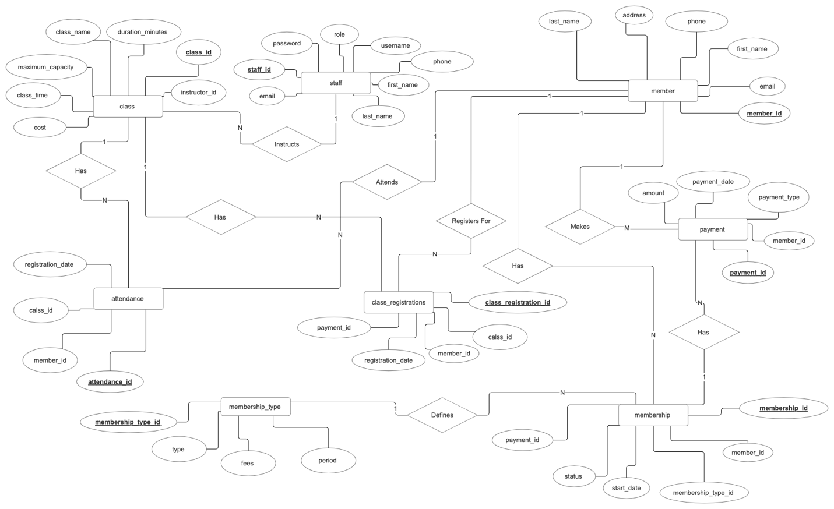

**ERD to relation schema mapping**

**SQL commands to create and insert data into the tables along with the screen shots**

CREATE TABLE member (

member_id INT DEFAULT member_seq.nextval PRIMARY KEY,

phone VARCHAR(20) UNIQUE NOT NULL,

email VARCHAR(100) UNIQUE NOT NULL,

first_name VARCHAR(50) NOT NULL,

last_name VARCHAR(50) NOT NULL,

address VARCHAR(200)

);

CREATE TABLE staff (

staff_id INT DEFAULT staff_seq.nextval PRIMARY KEY,

phone VARCHAR(20) UNIQUE NOT NULL,

email VARCHAR(100) UNIQUE NOT NULL,

first_name VARCHAR(50) NOT NULL,

last_name VARCHAR(50) NOT NULL,

password VARCHAR(100) NOT NULL,

username VARCHAR(50) UNIQUE NOT NULL,

role VARCHAR(20) NOT NULL

);

CREATE TABLE class (class_id INT DEFAULT class_seq.nextval PRIMARY KEY,

class_name VARCHAR(50) NOT NULL,

maximum_capacity INT NOT NULL,

class_time DATE NOT NULL,

duration_minutes INT NOT NULL,

cost NUMBER NOT NULL,

instructor_id INT NOT NULL CONSTRAINT class_staff_id_fk REFERENCES staff(staff_id));

CREATE TABLE membership_type (

membership_type_id INT DEFAULT membership_type_seq.nextval PRIMARY KEY,

fees DECIMAL(8) NOT NULL,

period VARCHAR(20) NOT NULL CHECK (period IN ('monthly', 'yearly')),

type VARCHAR(255) NOT NULL CONSTRAINT chk_membership_type CHECK (type IN ('Gold', 'Silver', 'Bronze')),

CONSTRAINT chk_fee CHECK (

(type = 'Gold' AND period = 'monthly' AND fees = 40) OR

(type = 'Gold' AND period = 'yearly' AND fees = 4000) OR

(type = 'Silver' AND period = 'monthly' AND fees = 25) OR

(type = 'Silver' AND period = 'yearly' AND fees = 3000) OR

(type = 'Bronze' AND period = 'monthly' AND fees = 30) OR

(type = 'Bronze' AND period = 'yearly' AND fees = 3500)

)

);

CREATE TABLE membership (

membership_id INT DEFAULT membership_seq.nextval PRIMARY KEY,

member_id INT NOT NULL,

membership_type_id INT,

start_date DATE NOT NULL,

status VARCHAR(50) NOT NULL CONSTRAINT CHK_MEMBERSHIP_status CHECK (status IN (' Active', ' Expired', ' Suspended')),

payment_id INT NOT NULL CONSTRAINT payment_id_fk REFERENCES payment(payment_id),

FOREIGN KEY (member_id) REFERENCES member(member_id),

FOREIGN KEY (membership_type_id) REFERENCES membership_type(membership_type_id)

);

CREATE TABLE class_registration (

class_registration_id INT DEFAULT class_registration_seq.nextval PRIMARY KEY,

registration_date DATE NOT NULL,

member_id INT NOT NULL CONSTRAINT class_reg_memberid_fk REFERENCES member(member_id),

class_id INT NOT NULL CONSTRAINT classid_fk REFERENCES class(class_id),

payment_id INT NOT NULL CONSTRAINT paymentid_fk REFERENCES payment(payment_id)

);

CREATE TABLE attendance (

attendance_id INT DEFAULT member_attendance_seq.nextval PRIMARY KEY,

registration_date DATE NOT NULL,

member_id INT NOT NULL CONSTRAINT class_reg_member_id_fk REFERENCES member(member_id),

class_id INT NOT NULL CONSTRAINT class_id_fk REFERENCES class(class_id)

);

CREATE TABLE payment (

payment_id INT DEFAULT payment_seq.nextval PRIMARY KEY,

payment_type VARCHAR(50) NOT NULL,

payment_date DATE NOT NULL,

amount DECIMAL(8) NOT NULL,

member_id INT NOT NULL CONSTRAINT payment_member_id_fk REFERENCES member(member_id)

);

**Data Samples**

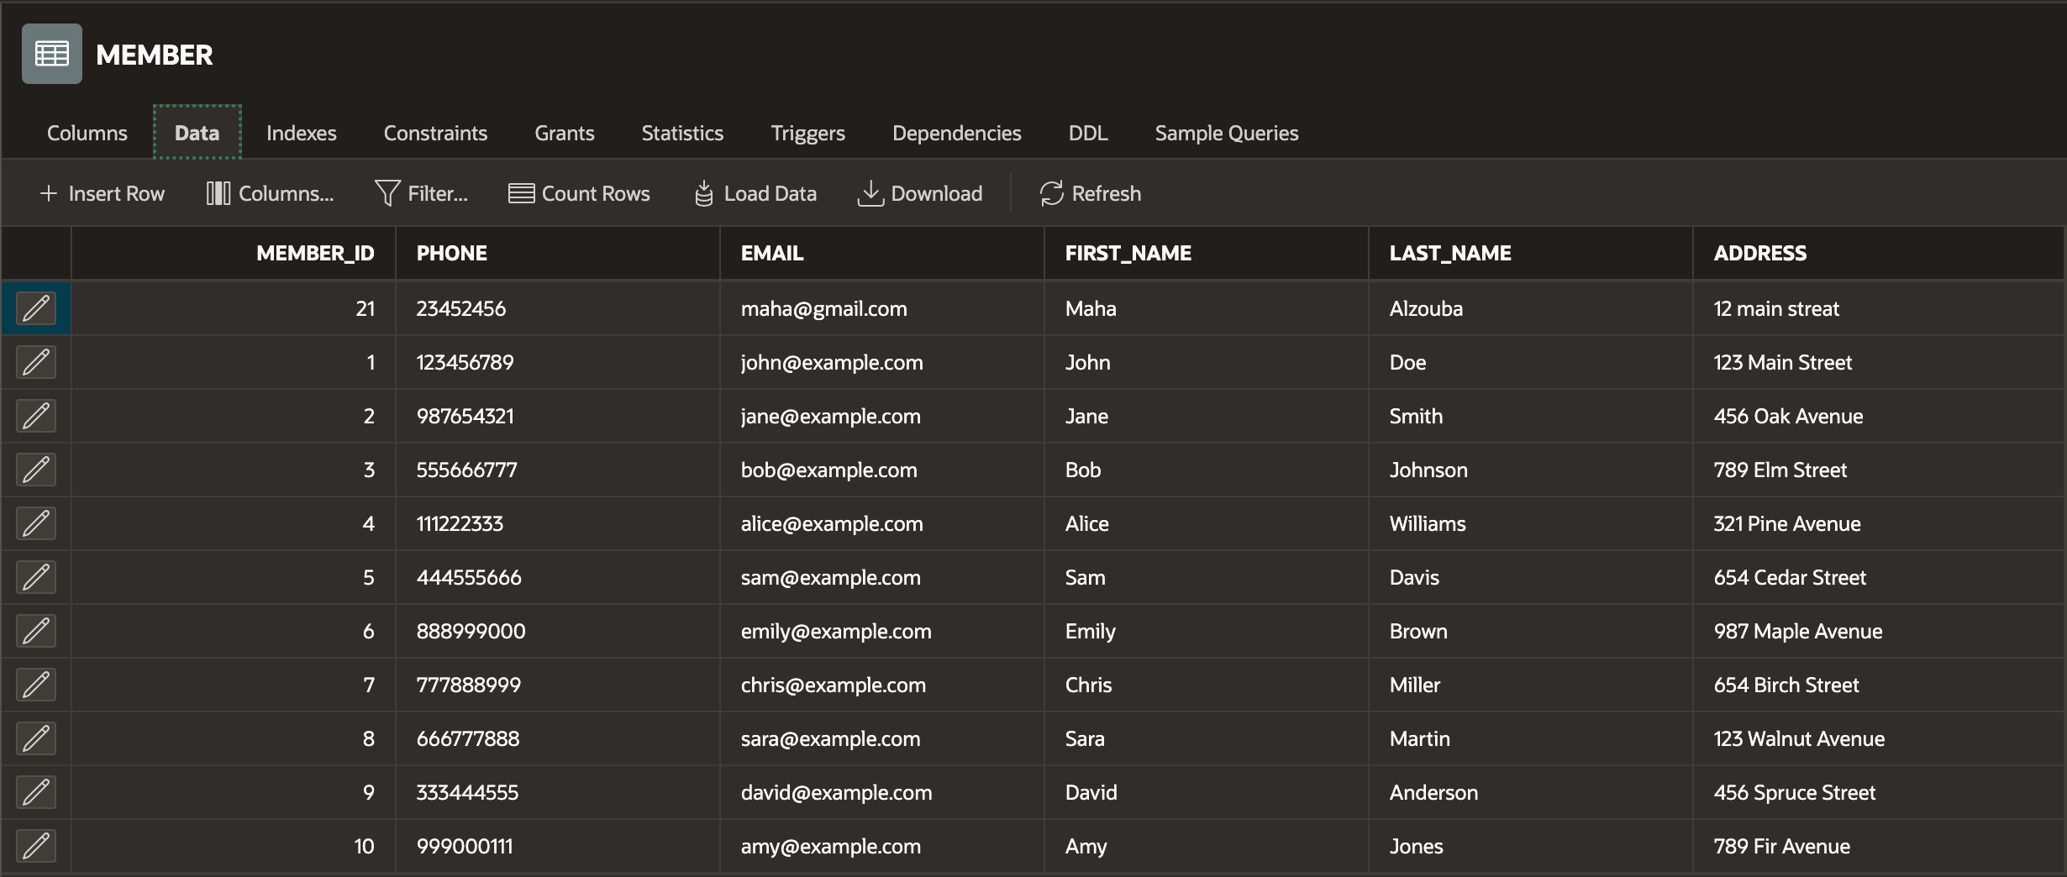

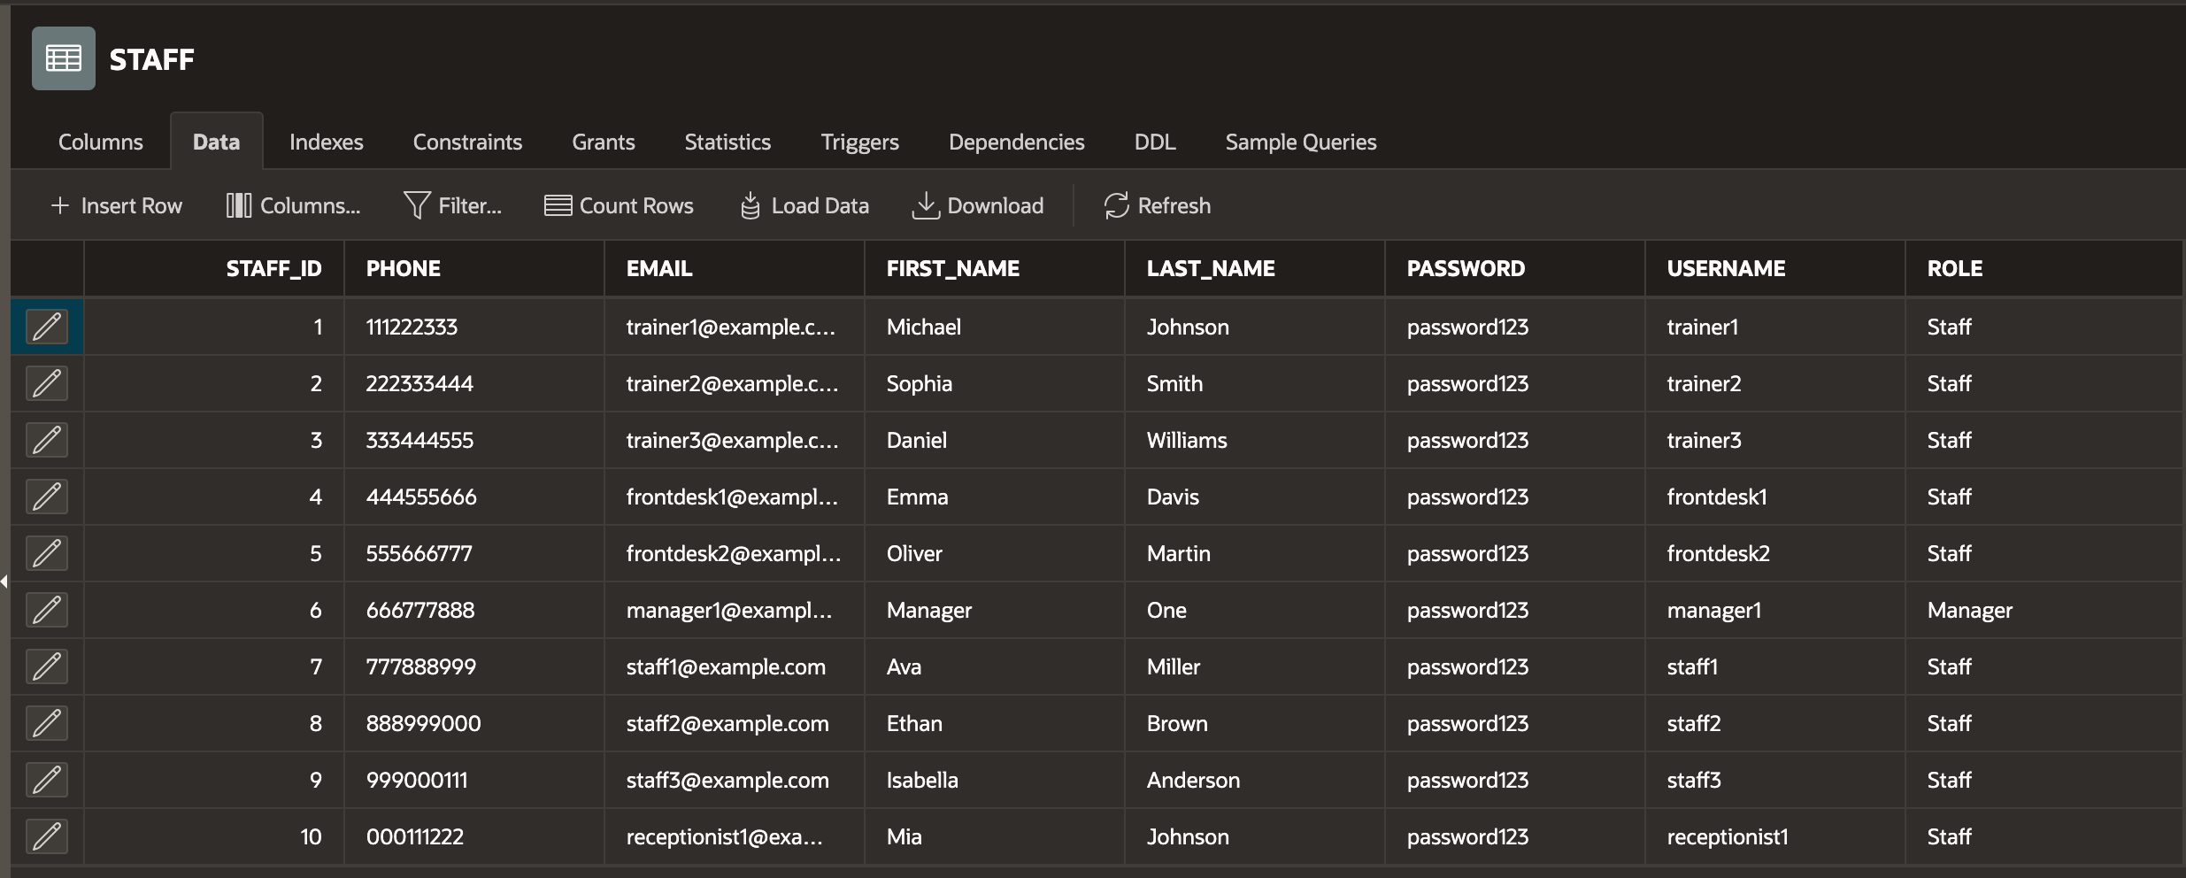

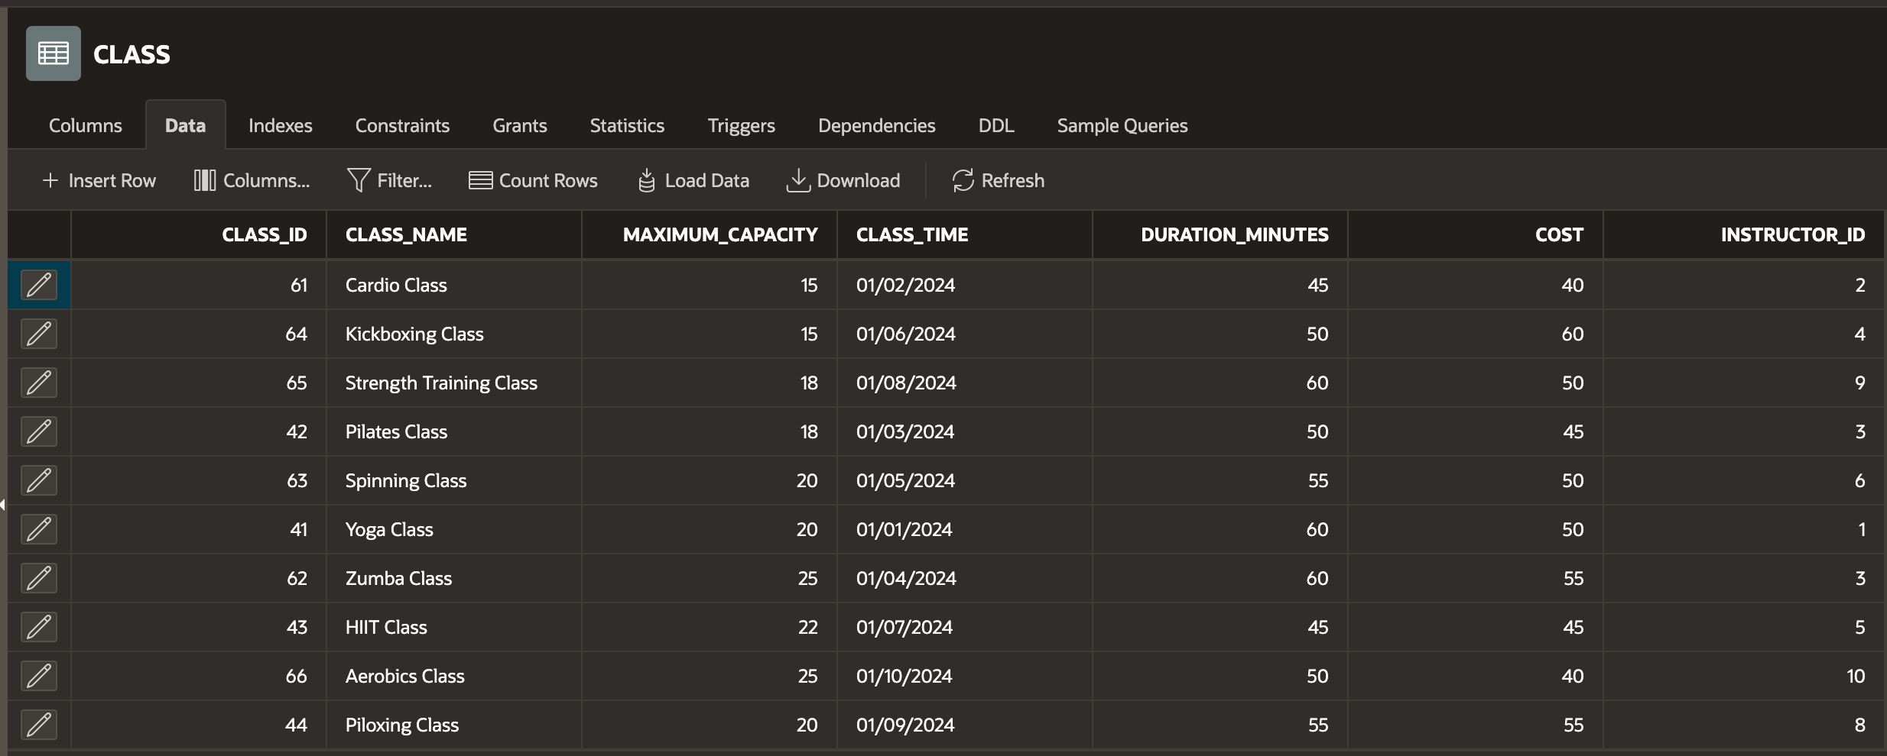

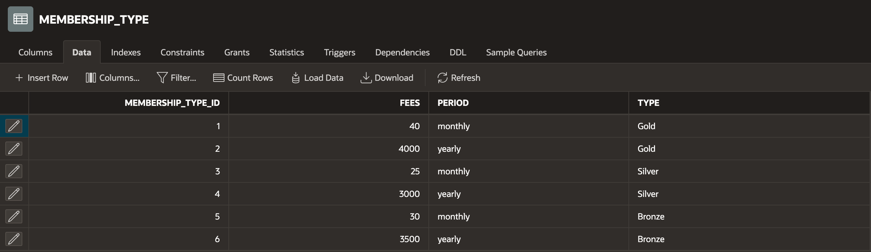

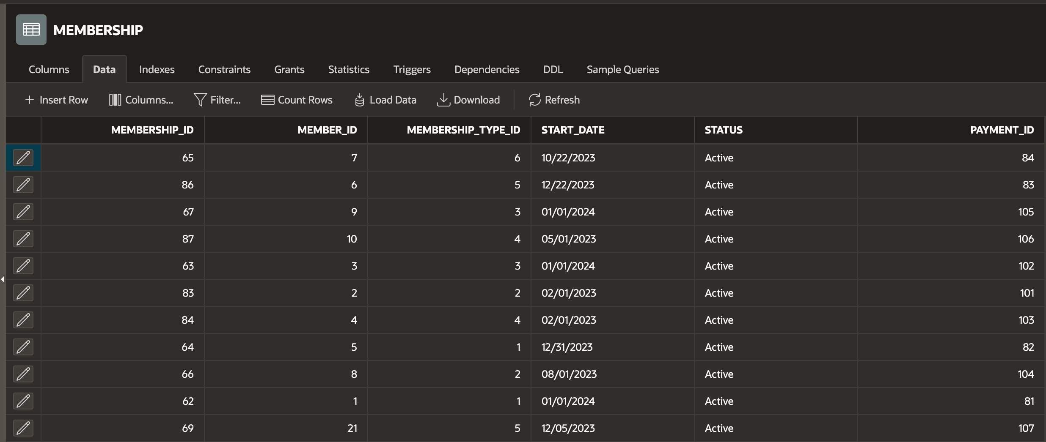

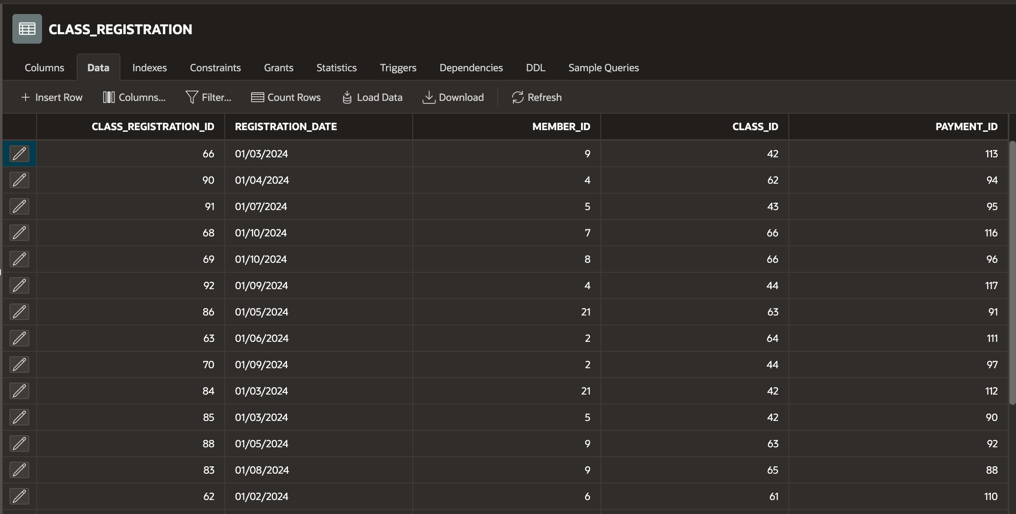

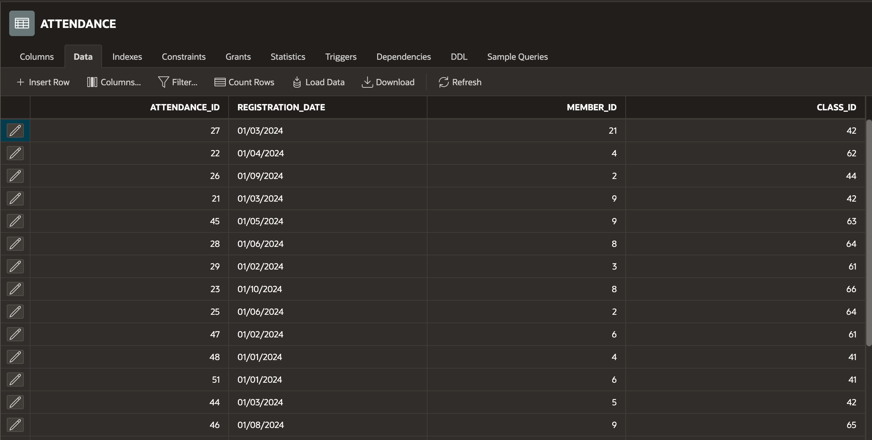

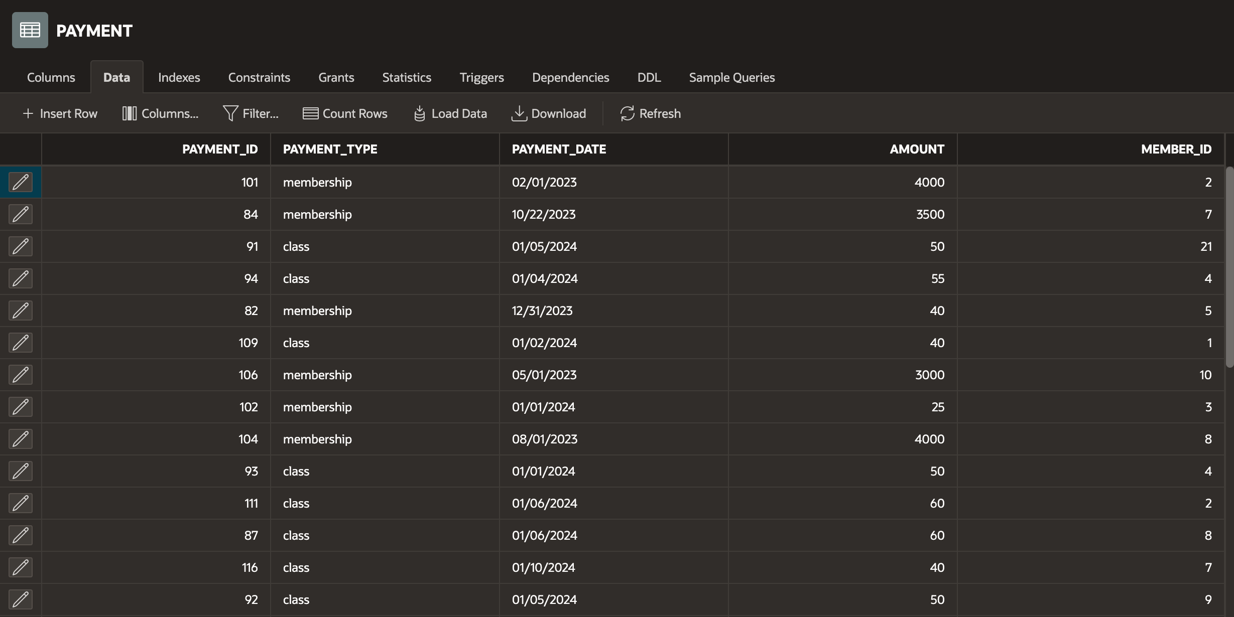

**screen captures of query/procedure results**

CREATE OR REPLACE PROCEDURE MonthlyReport (in_year NUMBER, in_month NUMBER) IS

BEGIN

FOR instructor_info IN (

SELECT s.staff_id, s.first_name, s.last_name, s.phone, s.email, s.role,

COUNT(DISTINCT cr.member_id) AS num_members, SUM(c.cost) AS total_profits

FROM class_registration cr

JOIN class c ON cr.class_id = c.class_id

JOIN staff s ON c.instructor_id = s.staff_id

WHERE EXTRACT(YEAR FROM cr.registration_date) = in_year

AND EXTRACT(MONTH FROM cr.registration_date) = in_month

GROUP BY s.staff_id, s.first_name, s.last_name, s.phone, s.email, s.role

) LOOP

DBMS_OUTPUT.PUT_LINE('Instructor ID: ' || instructor_info.staff_id);

DBMS_OUTPUT.PUT_LINE('Name: ' || instructor_info.first_name || ' ' || instructor_info.last_name);

DBMS_OUTPUT.PUT_LINE('Phone: ' || instructor_info.phone);

DBMS_OUTPUT.PUT_LINE('Email: ' || instructor_info.email);

DBMS_OUTPUT.PUT_LINE('Role: ' || instructor_info.role);

DBMS_OUTPUT.PUT_LINE('Number of Members: ' || instructor_info.num_members);

DBMS_OUTPUT.PUT_LINE('Total Profits: ' || instructor_info.total_profits);

DBMS_OUTPUT.PUT_LINE('------------------------');

END LOOP;

END MonthlyReport;

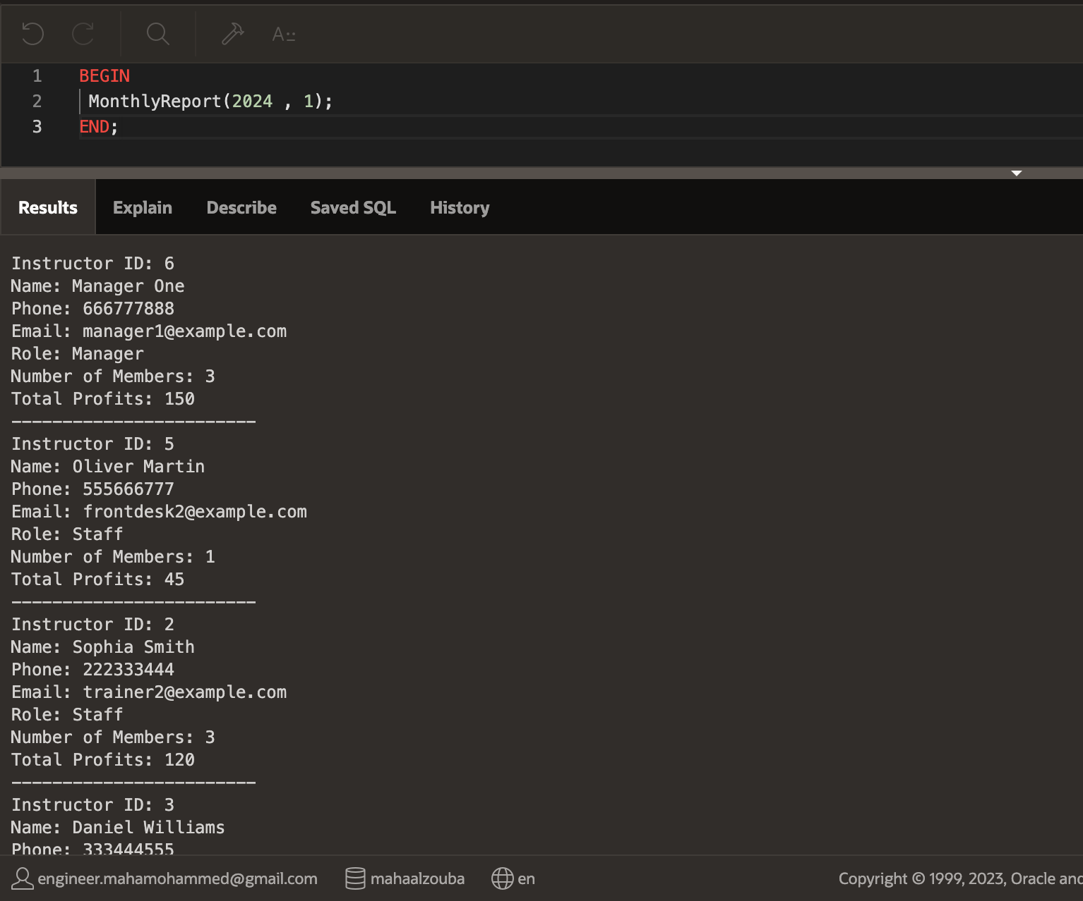

CREATE OR REPLACE PROCEDURE MemberServices (in_member_id INT) IS

BEGIN

FOR member_info IN (

SELECT m.*, cr.class_registration_id, cr.registration_date, c.class_name, c.class_time, c.duration_minutes, c.cost

FROM member m

JOIN class_registration cr ON m.member_id = cr.member_id

JOIN class c ON cr.class_id = c.class_id

WHERE m.member_id = in_member_id

) LOOP

DBMS_OUTPUT.PUT_LINE('Member ID: ' || member_info.member_id);

DBMS_OUTPUT.PUT_LINE('Phone: ' || member_info.phone);

DBMS_OUTPUT.PUT_LINE('Email: ' || member_info.email);

DBMS_OUTPUT.PUT_LINE('Address: ' || member_info.address);

DBMS_OUTPUT.PUT_LINE('Class Registration ID: ' || member_info.class_registration_id);

DBMS_OUTPUT.PUT_LINE('Registration Date: ' || TO_CHAR(member_info.registration_date, 'YYYY-MM-DD'));

DBMS_OUTPUT.PUT_LINE('Class Name: ' || member_info.class_name);

DBMS_OUTPUT.PUT_LINE('Class Time: ' || TO_CHAR(member_info.class_time, 'YYYY-MM-DD HH24:MI:SS'));

DBMS_OUTPUT.PUT_LINE('Duration Minutes: ' || member_info.duration_minutes);

DBMS_OUTPUT.PUT_LINE('Cost: ' || member_info.cost);

DBMS_OUTPUT.PUT_LINE('------------------------');

END LOOP;

END MemberServices;

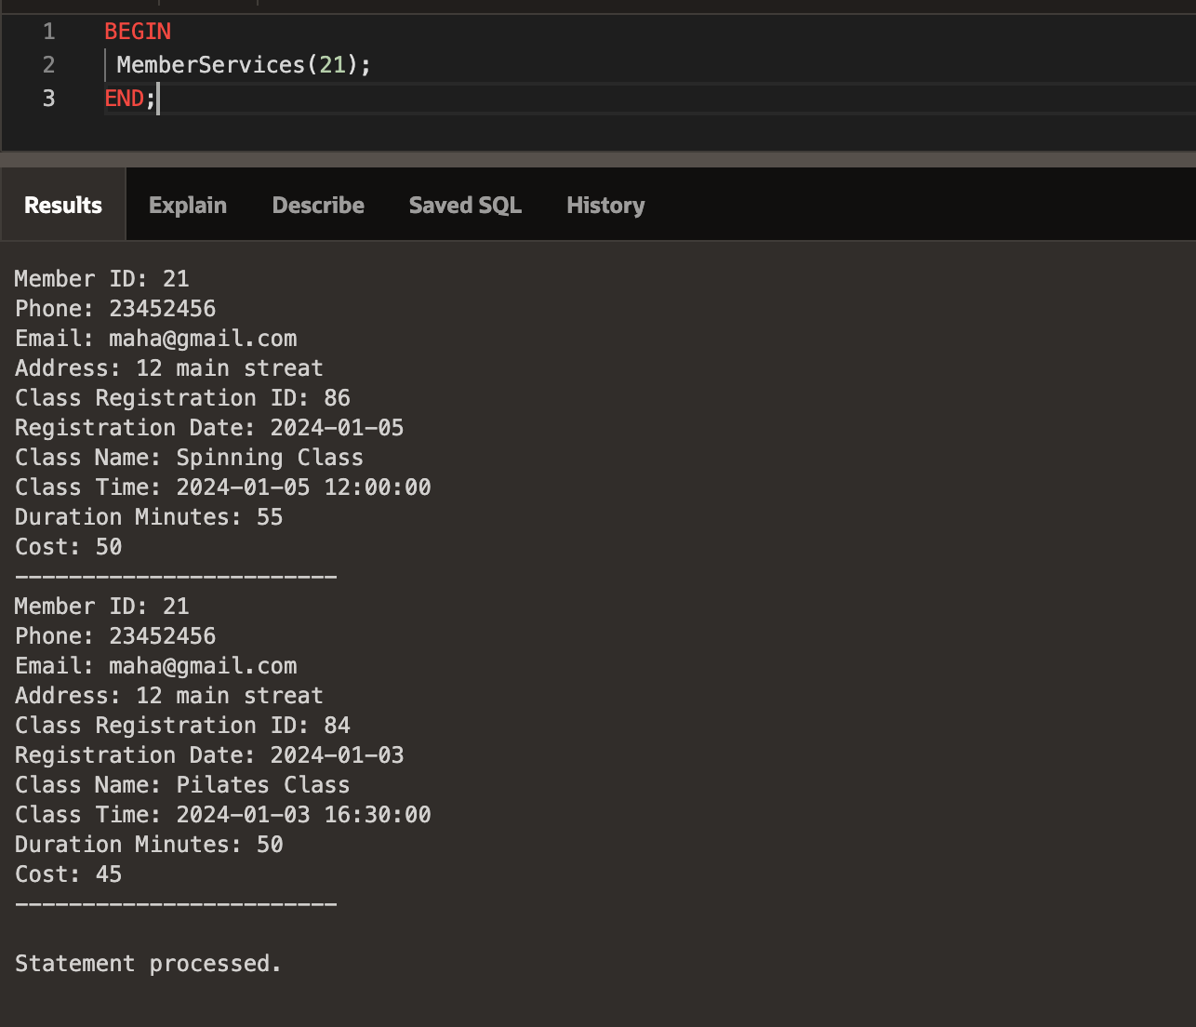

CREATE OR REPLACE PROCEDURE AddMember (

p_phone VARCHAR2,

p_email VARCHAR2,

p_first_name VARCHAR2,

p_last_name VARCHAR2,

p_address VARCHAR2,

p_membership_type VARCHAR2,

p_membership_period VARCHAR2

) IS

v_member_id INT;

v_membership_type_id INT;

v_payment_id_membership INT;

v_payment_id_payment INT;

v_membership_fee DECIMAL(8);

BEGIN

-- Step 1: Insert into member table

INSERT INTO member (member_id, phone, email, first_name, last_name, address)

VALUES (member_seq.nextval, p_phone, p_email, p_first_name, p_last_name, p_address)

RETURNING member_id INTO v_member_id;

-- Step 2: Get membership type ID and fee

SELECT membership_type_id, fees

INTO v_membership_type_id, v_membership_fee

FROM membership_type

WHERE type = p_membership_type AND period = p_membership_period;

-- Step 3: Insert into membership table without payment_id

INSERT INTO membership (membership_id, member_id, membership_type_id, start_date, status, payment_id)

VALUES (membership_seq.nextval, v_member_id, v_membership_type_id, SYSDATE, ' Active', NULL)

RETURNING payment_id INTO v_payment_id_membership;

-- Step 4: Insert into payment table with payment_id

INSERT INTO payment (payment_id, payment_type, payment_date, amount, member_id)

VALUES (payment_seq.NEXTVAL, 'membership', SYSDATE, v_membership_fee, v_member_id)

RETURNING payment_id INTO v_payment_id_payment;

-- Step 5: Update payment_id in membership table

UPDATE membership

SET payment_id = v_payment_id_payment

WHERE member_id = v_member_id;

COMMIT;

DBMS_OUTPUT.PUT_LINE('Member added successfully!');

EXCEPTION

WHEN OTHERS THEN

ROLLBACK;

DBMS_OUTPUT.PUT_LINE('Error: ' || SQLERRM);

END AddMember;

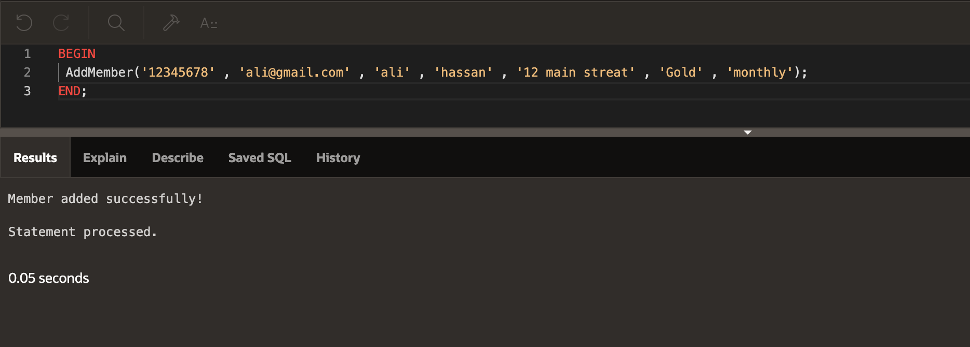

CREATE OR REPLACE PROCEDURE ClassStatus (

in_instructor_id INT

) IS

v_instructor_name VARCHAR2(100);

v_total_members INT := 0;

v_total_profits DECIMAL(8, 2) := 0;

BEGIN

-- Get the instructor's name

SELECT first_name || ' ' || last_name INTO v_instructor_name

FROM staff

WHERE staff_id = in_instructor_id;

-- Display the instructor's name

DBMS_OUTPUT.PUT_LINE('Instructor: ' || v_instructor_name);

-- Iterate through classes

FOR class_info IN (

SELECT c.class_id, c.class_name, c.maximum_capacity, c.class_time, c.duration_minutes, c.cost,

COUNT(cr.member_id) AS enrolled_members,

(COUNT(cr.member_id) * c.cost) AS total_profit

FROM class c

LEFT JOIN class_registration cr ON c.class_id = cr.class_id

WHERE c.instructor_id = in_instructor_id

AND c.class_time > SYSDATE

GROUP BY c.class_id, c.class_name, c.maximum_capacity, c.class_time, c.duration_minutes, c.cost

) LOOP

DBMS_OUTPUT.PUT_LINE('Class ID: ' || class_info.class_id);

DBMS_OUTPUT.PUT_LINE('Class Name: ' || class_info.class_name);

DBMS_OUTPUT.PUT_LINE('Maximum Capacity: ' || class_info.maximum_capacity);

DBMS_OUTPUT.PUT_LINE('Class Time: ' || TO_CHAR(class_info.class_time, 'YYYY-MM-DD HH24:MI:SS'));

DBMS_OUTPUT.PUT_LINE('Duration Minutes: ' || class_info.duration_minutes);

DBMS_OUTPUT.PUT_LINE('Cost: ' || class_info.cost);

DBMS_OUTPUT.PUT_LINE('Enrolled Members: ' || class_info.enrolled_members);

DBMS_OUTPUT.PUT_LINE('Total Profit: ' || class_info.total_profit);

DBMS_OUTPUT.PUT_LINE('------------------------');

-- Update totals

v_total_members := v_total_members + class_info.enrolled_members;

v_total_profits := v_total_profits + class_info.total_profit;

END LOOP;

-- Display totals

DBMS_OUTPUT.PUT_LINE('Total Enrolled Members: ' || v_total_members);

DBMS_OUTPUT.PUT_LINE('Total Expected Profits: ' || v_total_profits);

EXCEPTION

WHEN NO_DATA_FOUND THEN

DBMS_OUTPUT.PUT_LINE('Instructor not found.');

WHEN OTHERS THEN

DBMS_OUTPUT.PUT_LINE('Error: ' || SQLCODE || ' - ' || SQLERRM);

END ClassStatus;

**Screen captures of different Forms and Reports with explanation.**

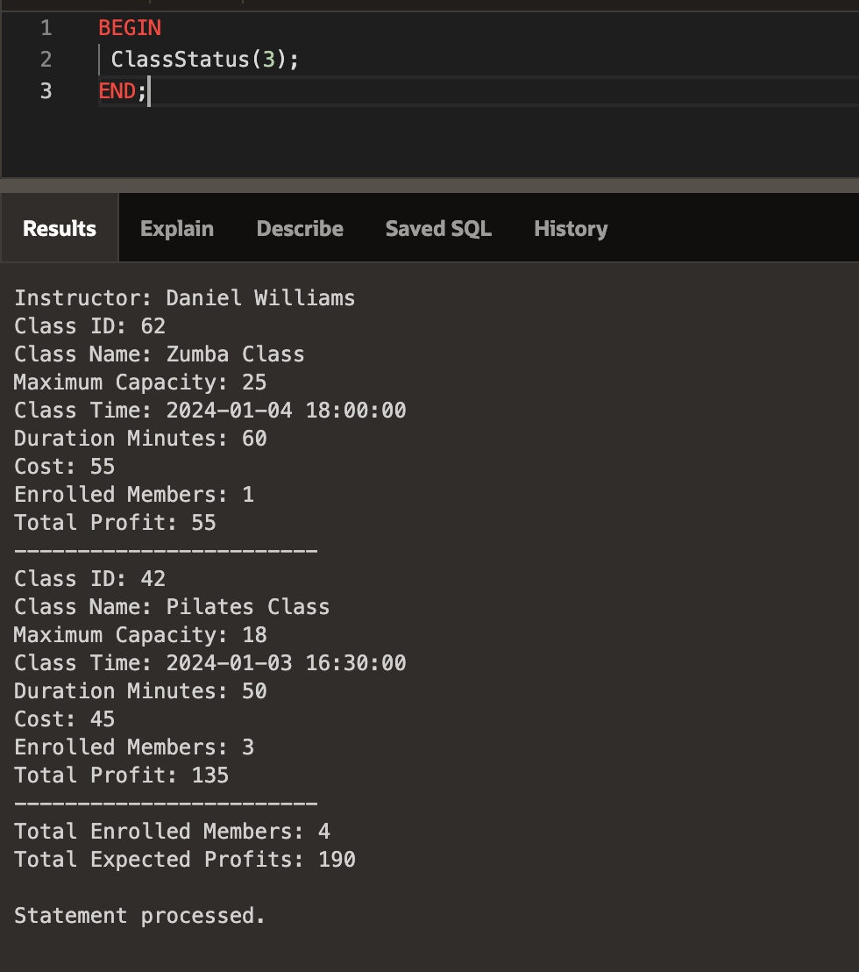

CREATE OR REPLACE PROCEDURE ClassRegistration(p_class_id INT, p_member_id INT) AS

v_enrollment_count INT;

v_max_capacity INT;

v_payment_id INT;

v_membership_start_date DATE;

v_membership_end_date DATE;

v_membership_type_period VARCHAR2(20);

v_class_date DATE;

v_class_cost NUMBER;

v_existing_registration INT;

BEGIN

-- Check if the provided member_id is valid

IF NOT Check_member_id(p_member_id) THEN

DBMS_OUTPUT.PUT_LINE('Invalid member ID. Registration failed.');

RETURN;

END IF;

-- Check if the provided class_id is valid

IF NOT Check_class_id(p_class_id) THEN

DBMS_OUTPUT.PUT_LINE('Invalid class ID. Registration failed.');

RETURN;

END IF;

-- Check if the member is already registered for the class

SELECT COUNT(*) INTO v_existing_registration

FROM class_registration

WHERE class_id = p_class_id AND member_id = p_member_id;

IF v_existing_registration > 0 THEN

DBMS_OUTPUT.PUT_LINE('Member is already registered for the class. Registration not allowed.');

RETURN;

END IF;

BEGIN

-- Retrieve the current enrollment count for the class

SELECT COUNT(*) INTO v_enrollment_count FROM class_registration WHERE class_id = p_class_id;

-- Retrieve the maximum capacity for the class

SELECT maximum_capacity INTO v_max_capacity FROM class WHERE class_id = p_class_id;

-- Retrieve the membership start date and type period for the member

SELECT start_date, period INTO v_membership_start_date, v_membership_type_period

FROM membership_type mt

JOIN membership m ON mt.membership_type_id = m.membership_type_id

WHERE m.member_id = p_member_id AND m.status = ' Active';

-- Retrieve the class date and cost

SELECT class_time, cost INTO v_class_date, v_class_cost FROM class WHERE class_id = p_class_id;

-- Calculate the membership end date based on the type period

IF v_membership_type_period = 'monthly' THEN

v_membership_end_date := ADD_MONTHS(v_membership_start_date, 1);

ELSIF v_membership_type_period = 'yearly' THEN

v_membership_end_date := ADD_MONTHS(v_membership_start_date, 12);

END IF;

-- Check if there is still capacity for enrollment

IF v_enrollment_count < v_max_capacity THEN

-- Check if the class date is before the membership end date

IF v_class_date < v_membership_end_date THEN

-- Generate a new payment_id

v_payment_id := PAYMENT_SEQ.NEXTVAL;

-- Insert the new registration into the payment table

INSERT INTO payment(payment_id, payment_type, payment_date, amount, member_id)

VALUES (v_payment_id, 'class', SYSDATE, v_class_cost, p_member_id);

-- Insert the new registration into the class_registration table

INSERT INTO class_registration(class_registration_id, member_id, class_id, registration_date, payment_id)

VALUES (class_registration_seq.NEXTVAL, p_member_id, p_class_id, SYSDATE, v_payment_id);

-- Display success message

DBMS_OUTPUT.PUT_LINE('Member successfully registered for the class.');

ELSE

-- Display error message if the class date is after the membership end date

DBMS_OUTPUT.PUT_LINE('Class date is after the member''s membership end date. Registration not allowed.');

END IF;

ELSE

-- Display error message if the class is already at full capacity

DBMS_OUTPUT.PUT_LINE('Class is already at full capacity. Registration not allowed.');

END IF;

EXCEPTION

WHEN NO_DATA_FOUND THEN

DBMS_OUTPUT.PUT_LINE('Error: No data found during registration.');

WHEN OTHERS THEN

-- Display detailed error message if any error occurs during the registration process

DBMS_OUTPUT.PUT_LINE('Error: ' || SQLCODE || ' - ' || SQLERRM);

END;

END;

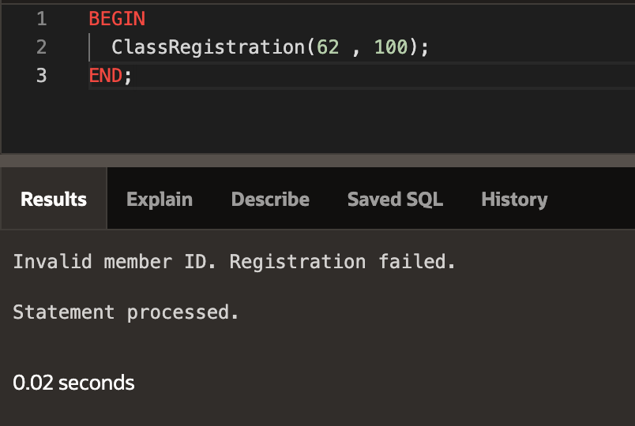

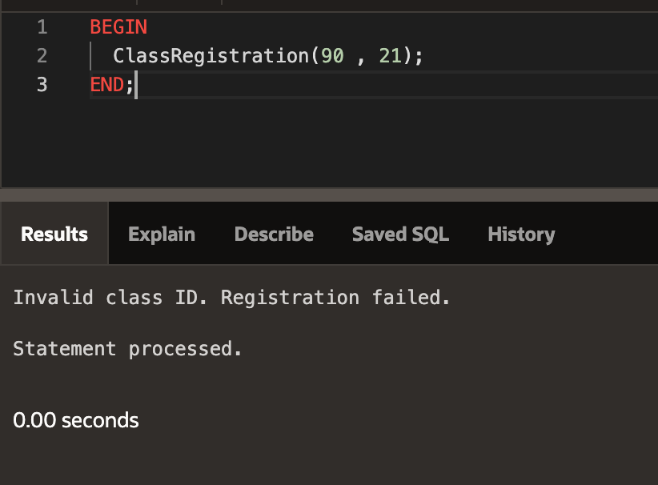

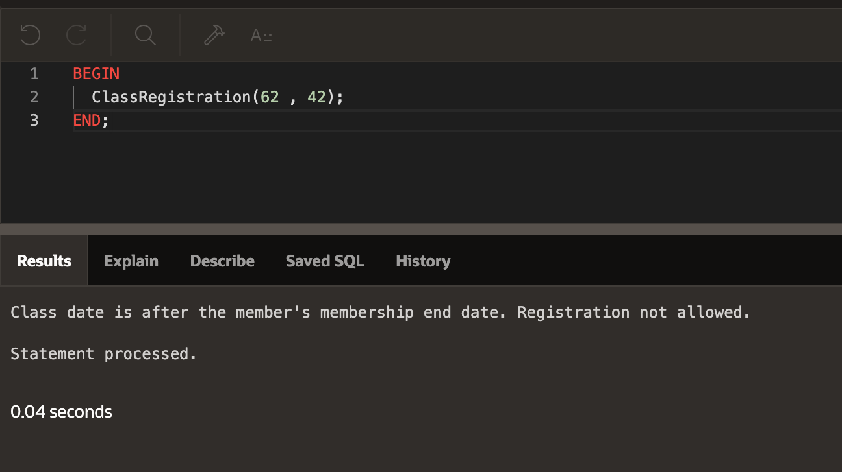

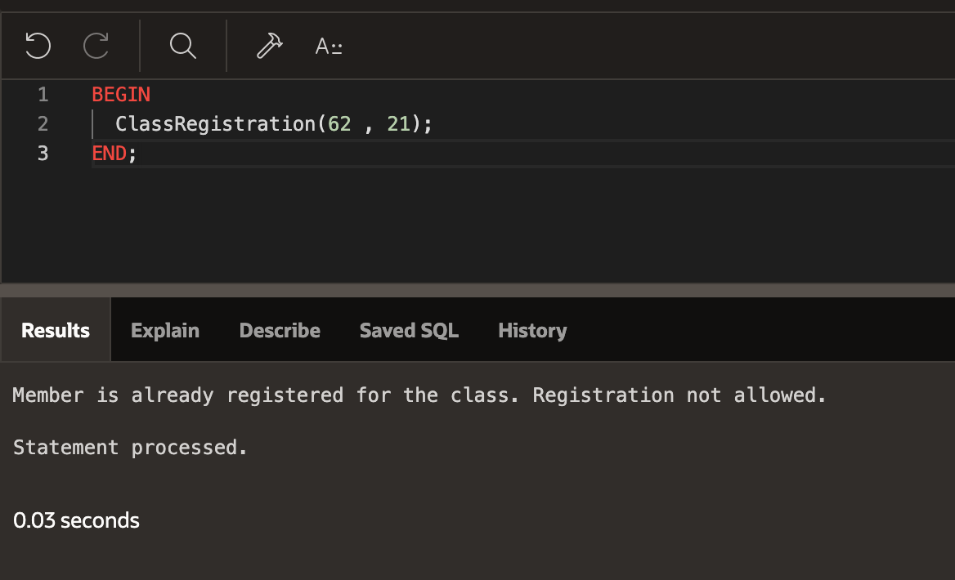

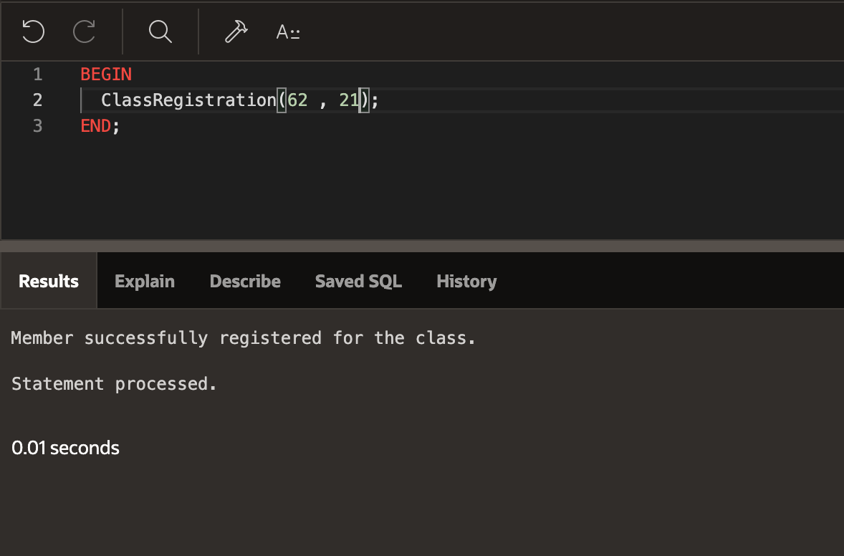

CREATE OR REPLACE PROCEDURE UpdateMembershipStatus AS

BEGIN

-- Update monthly memberships

UPDATE membership

SET status = ' Expired'

WHERE status = ' Active' AND membership_type_id IN (

SELECT membership_type_id

FROM membership_type

WHERE period = 'monthly'

) AND SYSDATE > ADD_MONTHS(start_date, 1);

-- Update yearly memberships

UPDATE membership

SET status = ' Expired'

WHERE status = ' Active' AND membership_type_id IN (

SELECT membership_type_id

FROM membership_type

WHERE period = 'yearly'

) AND SYSDATE > ADD_MONTHS(start_date, 12);

COMMIT;

END UpdateMembershipStatus;

-- Create a job to run the UpdateMembershipStatus procedure every day at a specific time

BEGIN

DBMS_SCHEDULER.create_job (

job_name => 'UPDATE_MEMBERSHIP_JOB',

job_type => 'PLSQL_BLOCK',

job_action => 'BEGIN UpdateMembershipStatus; END;',

start_date => SYSTIMESTAMP,

repeat_interval => 'FREQ=DAILY; BYHOUR=0; BYMINUTE=0; BYSECOND=0',

enabled => TRUE

);

END;

/